**Meta Description:** Whales bet on FloppyPepe (FPPE) for 5,739% gains amidst Shiba Inu (SHIB) reversal predictions.

**Keywords:**

Shiba Inu price

Shiba Inu

AI Agent Altcoin

FloppyPepe

FPPE

# **Shiba Inu Price Prediction: Bullish Reversal Expected As Whales Quietly Accumulate New AI Agent Altcoin For 5,739% Surge**

The Shiba Inu price has shown signs of a bullish reversal and sparked renewed optimism among traders. However, while investors eye a potential breakout, crypto whales are quietly accumulating a new AI agent altcoin that offers more than just speculative price movements. [FloppyPepe (FPPE)](https://floppypepe.io/) has become the top choice among seasoned investors due to its sophisticated technology and passive income rewards.

With analysts predicting a 5,739% surge, FloppyPepe (FPPE) is quickly becoming the go-to investment for those seeking explosive returns. As whale accumulation intensifies, will the Shiba Inu price potential breakout be enough to compete with FloppyPepe's (FPPE) cutting-edge AI ecosystem and long-term profitability?

## **Shiba Inu Price: "Shiba Inu (SHIB) Looks Ready To Breakout This Bullish Wedge"**

An analyst [has said](https://x.com/army_shiba/status/1889318320043704326?s=46) that [Shiba Inu (SHIB)](https://www.coingecko.com/en/coins/shiba-inu) is set for a massive reversal with a potential for a 167% upside. Five days later, another analyst [corroborated](https://x.com/shibmortal/status/1891002332948611391?s=46) this Shiba Inu price prediction. In their words, "a reversal is imminent" after the Shiba Inu price has shown signs of breaking out of the bullish wedge. However, the 167% uptick for the Shiba Inu price pales before an incoming 5,739% surge by FloppyPepe (FPPE).

## **FloppyPepe (FPPE): The AI Agent Altcoin Promises Early 5,739% Gains Amidst Long-term Profits**

At the start of 2025, a crypto expert [predicted](https://x.com/elliotrades/status/1875266508558917669?s=46) that 2025 would be "the biggest expansion in crypto history." They added that AI cryptos will do well, but AI agents will drive the first massive expansion of the year by Q2. Hence, analysts have predicted that [FloppyPepe](https://floppypepe.io/) (FPPE), a new AI agent altcoin will surge by 5,739% before June. Industry experts agree with this prediction as they invested over $900,000 within 24 hours in the private round of this presale event.

The AI agent altcoin provides access to trendy technology that helps crypto beginners and experts survive the turbulent market. The network's **AI text-to-image** technology, which is now live on the Telegram channel, helps interested individuals to create and monetize digital content. It also has an **AI video agent** for new members to learn and make informed decisions about trading. Hence, FloppyPepe (FPPE) functions as an AI agent.



As an AI crypto, FloppyPepe (FPPE) has slowly become the market's favorite with its predictive model. It also has an **AI-powered Meme-o-Matic machine** that helps traders transform viral memes into a source of income. As such, a top YouTuber, NASS Crypto, has backed this AI agent altcoin as one of the best-performing AI crypto in the coming years. As the year progresses, the network will release more features to improve traders' experience on the platform.

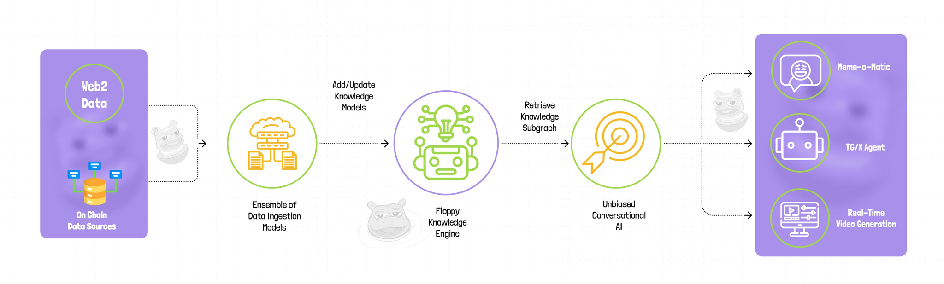

Other than its commitment to technology, there are numerous ways to earn money on FloppyPepe (FPPE). All token holders receive a 3% payback on every transaction to promote sustainability. The **deflationary burn mechanism** similarly drives value appreciation by creating scarcity. This AI agent altcoin also shares a part of its revenue with wildlife efforts to show its commitment to social preservation.

There is no worry about infringement or theft as FloppyPepe (FPPE) completed a [smart audit contract](https://app.solidproof.io/projects/floppypepe) by SolidProof. Hence, traders can watch their **$0.0000002** asset grow from cents to millions of dollars. The affordable entry point has encouraged new traders who want to enjoy the incoming 5,739% surge.

## **FloppyPepe (FPPE): The AI Agent Altcoin With Long-term Profitability**

Crypto experts look beyond the Shiba Inu price potential breakout for an AI agent altcoin because they want real value over menial gains. Well, the real play here is [FloppyPepe (FPPE)](https://floppypepe.io/). Whales are loading up, analysts are screaming 5,739% gains, and the presale is flying. Hence, the potential breakout of the Shiba Inu price cannot compete with FloppyPepe's (FPPE) cutting-edge AI ecosystem and long-term profitability.

FloppyPepe's (FPPE) AI-powered ecosystem and passive income rewards have redefined the game. While Shiba Inu (SHIB) holders wait and see, savvy investors are locking in their positions for explosive returns. FloppyPepe (FPPE) is not just another meme coin but a rocket ship primed for launch. This AI agent altcoin is ready to rewrite the rules of crypto gains.

**Join the FloppyPepe (FPPE) presale and community:   
Website:** [**https://floppypepe.io/**](https://floppypepe.io/) **Whitepaper:** [**https://floppypepe.gitbook.io/floppypepe.io**](https://floppypepe.gitbook.io/floppypepe.io) **Telegram:** [**https://t.me/floppypepeofficial**](https://t.me/floppypepeofficial) **X (Twitter):** [**https://x.com/floppypepe**](https://x.com/floppypepe)

